**INVOICING OPTIONS**

**Paperless Invoicing and Invoices for Postage by Mail Only**

The Paperless Invoice? toggle box works in conjunction with the Invoice Printing options in order processing. When this is checked, the program will only allow output to email. When output to a printer, invoice for this customer will not print thus saving the cost of paper as well as the cost of postage and labor stuffing the envelopes. When this is unchecked, then output to printer is allowed.

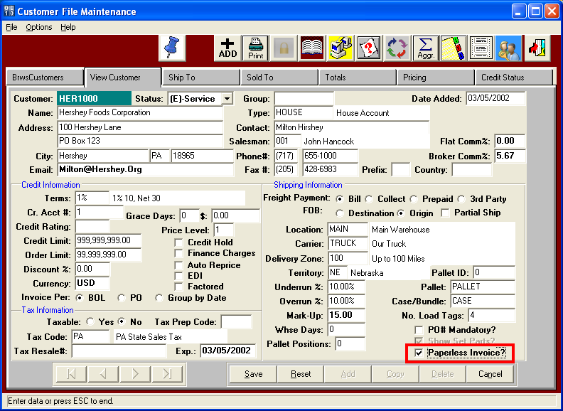

**Paperless Invoicing and Invoices for Mail Only**

Any customers invoice can be emailed by clicking the email toggle box regardless of the customer field setting for Paperless Invoice. However, when clicking the email and BATCH EMAIL option, only customers set to Paperless Invoice will be emailed in the batch range of customer invoices selected. Customer not defined as paperless invoice will be bypassed when batch emailing. The paperless invoice toggle box works in conjunction with the Invoice Printing options in order processing. When this is checked, the program will only allow output to email. When output to a printer, invoices for this customer will not print thus saving the cost of paper as well as the cost of postage and labor stuffing the envelopes. When this is unchecked, then output to customer invoice will print only for customers that want mailed invoices. Please note, all options can be overwritten by clicking the toggle box “Ignore Paperless Setting?. Meaning, we can still print invoices for paperless clients and email mail only clients.

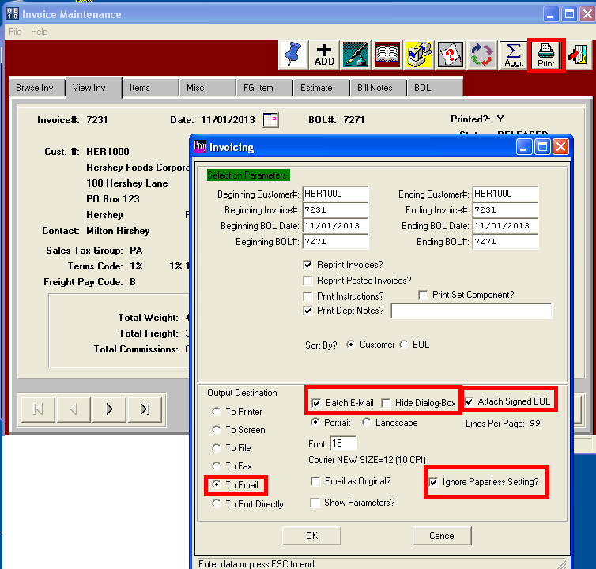

**EMAIL CONTACTS FOR INVOICING**

Once you click the OK button to email or batch email the invoice, all customers set to paperless invoice will automatically be emailed. In the sample, you will see in RED the contacts that were automatically transferred to the SENT TO window. The invoice form is automatically converted into a .PDF file that can be easily read by your customer. In addition, if you check the toggle box to include a signed bill of lading, another attachment will be added for the signed bill of lading from. The Hide Toggle Box will hide this Microsoft email display in background and process one customer after another until the entire batch is completed. The entire process will require no manual intervention. Of course if there are invalid emails or no contact defined for a customer, the program will either skip that customer or may pause until you select a contract to be emailed.

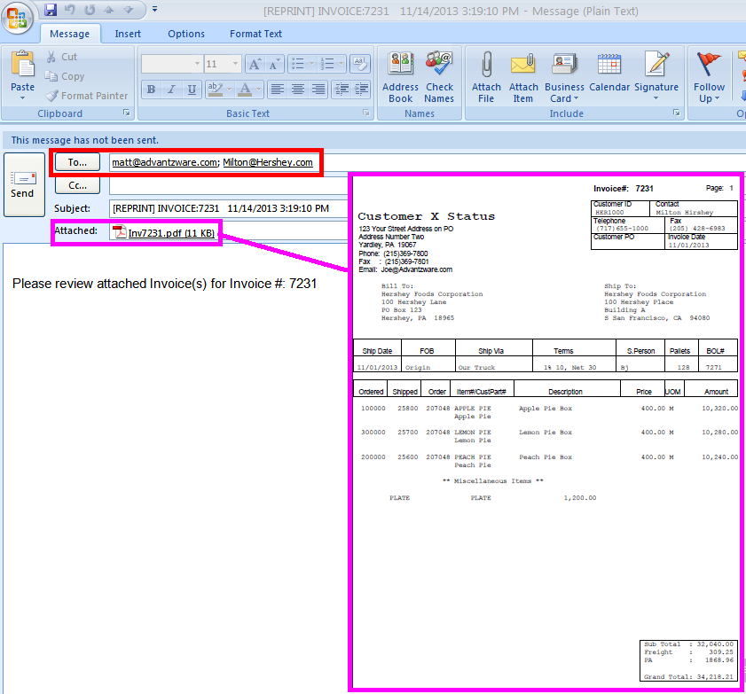

**EMAIL CONTACTS FOR INVOICING**

The Advantzware email notification logic allows your business to maintain a company- wide email database that works in conjunction with Microsoft Outlook. Instead of each employee maintaining their own Microsoft Address Book, you can now house the key contacts by customer. The email contacts for invoicing must be setup so that batch emailing invoices can transfer the SEND TO Contacts to the email for each invoice. First, contacts must be added for each customer in the customer file via the phone icon. Define unlimited contacts for each department so that you effortlessly email invoices, quotes, advanced ship notices, statements, inventory reports and much more.

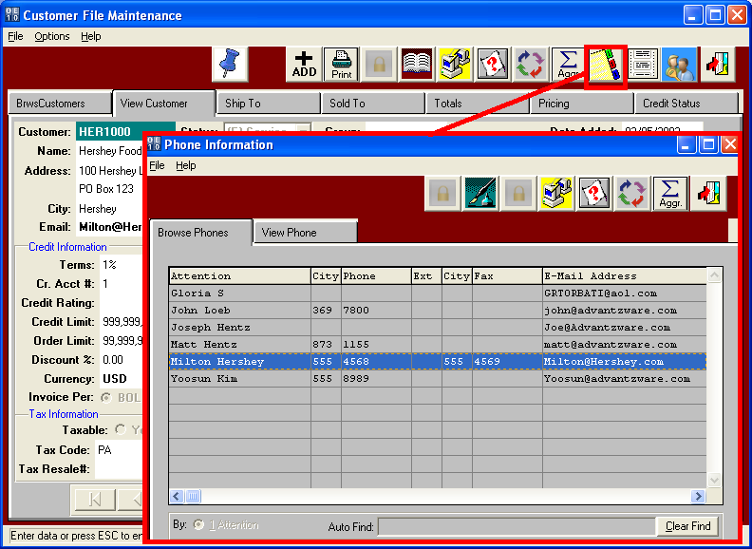

**EMAIL CONTACTS FOR INVOICING**

Each Contact must have their valid email address entered and each contact must be set to E-Mail Notification. Once this toggle box is checked, then the program name on the right indicates what business forms and reports are sent to this contact. To email invoices, the program R-InvPrint must be set to YES for as many contacts desired that you want to receive the invoice. So set up the controller, purchasing agent, sales rep and account payable clerk to receive your invoice simultaneously. In addition to email services, each contact can have unlimited notes via the Fountain Pen Icon. This provides a great marketing and customer service tool that allows each department to keep track of detailed conversations by date and topic. Sales calls, collection calls, plant directions, personal notes, company notes, quote history notes and unlimited topics can be saved by contact.

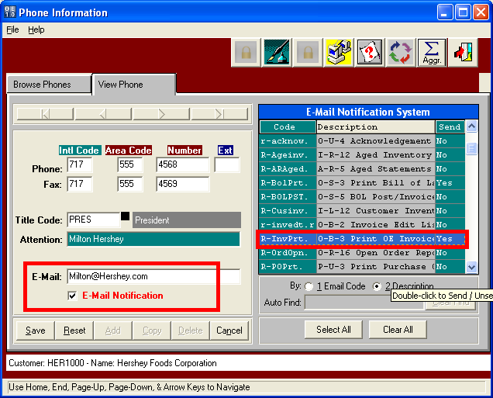

**ECODES for EMAIL CONTACTS FOR INVOICING**

Once contacts are added to the customer and each contact has valid email address, the Email codes file will be automatically updated for each file. The entire list of contacts by customer by program can be view on the Email Codes file. You can ADD or DELETE contact to any email program under the Ecodes file. You can add by title to speed the data entry process.

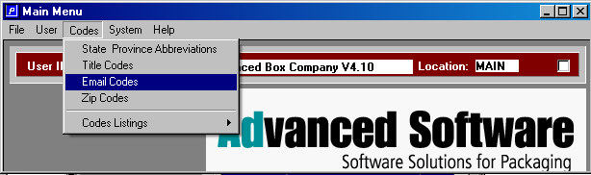

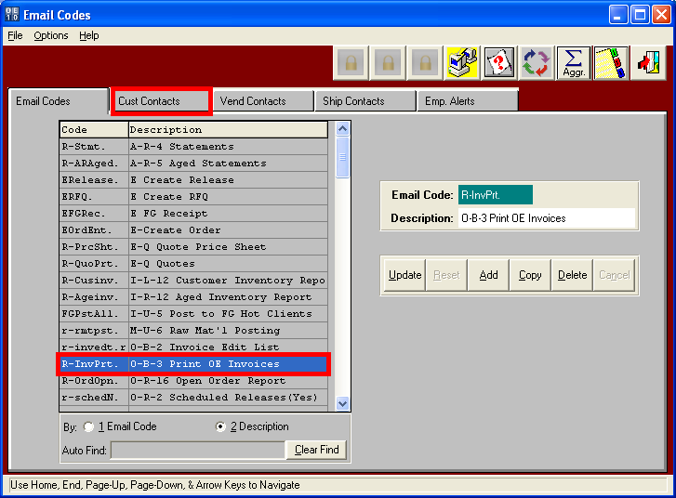

**ECODES for EMAIL CONTACTS FOR INVOICING**

All the AVAILABLE contacts added to the customers phone contacts are listed on the bottom window.

The Box enclosed with a PINK box are contacts set for email notification in the customer file. You can select any contact or all contact by customer or by Title, then once selected you click the ADD Button to move the contacts to the Program. All contacts set to receive invoices via email are in the top window. Contacts can be deleted simply by selecting a contact or a range of contacts by customer or title, the clicking the DELETE Button. Please note, this is the same file that can be updated when selecting the email program for a contact in the customer files, phone Icon table.

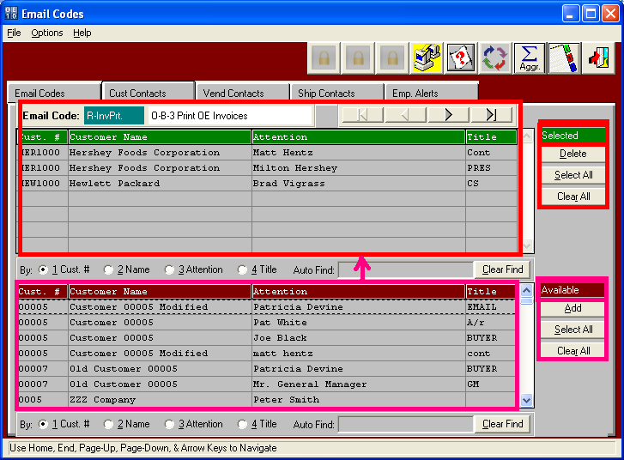

**SCANNING and SAVING SIGNED BILL OF LADINGS**

Character Value: Enter the location where you save the scanned bill of lading files. You must create a folder on your network drive to house the Signed Bill of Lading. Right Mouse Click on the Start Button on the Bottom Left and Add this Folder.

Logical value = YES will allow the user to scan a signed copy of a Bill of Lading and attach the .Jpg or .Bmt file to the posted BOL. The scanned BOL must be saved as the file name = BOL#.. The User will scan BOL document and save the file using the posted BOL number. The O-Q-1, looks up the order, clicks on the "Invoice" tab, and in the window that comes up, clicks on "BOL" tab. NEW Button called "Signed BOL". This will view / print the Jpeg. Scanned BOLs will be saved as JPEG files with filenames "bol_number.jpg" (for example, 82703.jpg), in the directory that is set under N-K-1 BOLSIGN Character value. If file "bol_number.jpg" does not exist, the "SIGNED BOL button will be Disabled, and clicking the button would Prompt "Signed receipt Unavailable".

When Bill of Lading are returned to your office with a signature, someone must Scan each bill of lading and Save them with the BOL number as the File Name. Each BOL must be saved in the folder assigned to the character Value Below.

